**Question-6 Wireshark Analysis**

Q-1? Ans:Hydra

Q-2?Ans:jenny

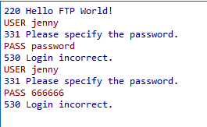

Q-3?Ans:password123

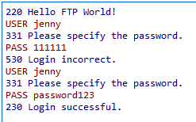

Q-4?Ans:"/var/www/html" is the current directory

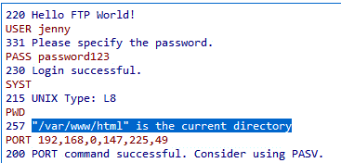

Q-5?Ans:shell.php

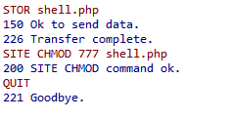

Q-6?Ans:www-data



Q-7?Ans:python3 -c 'import pty; pty.spawn("/bin/bash")'

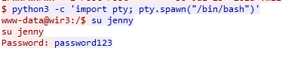

Q-8?Rootkit